Project Information
Client Name | Self-directed portfolio project — Beginner-Friendly Coffee Guide
Curriculum title | Everyday Life Skills
Course Title | How to Make Coffee
Versions
Date | Member Name | Role | Version | Affected Pages | Comment
29/08/2026 | Mohamed Sherif | E-Learning Developer | 1.0 | All | Initial full draft — coffee basics, types, brewing steps, and quiz
07/10/2026 | Mohamed Sherif | E-Learning Developer | 2.0 | Screens 02–08, Notes | Storyboard updated to match Storyline: added a readiness-check screen (05), redesigned Q1 as drag-and-drop and Q2 as an interactive brewing simulation, removed Q3, and updated the Results screen and progress indicators.

ID Name | CFE_S01_Welcome
Screen Type | Static — Title Screen
Screen Template | Title Screen Template
Screen Number | 01
Chapter Title | How to Make Coffee
Lesson Title | Lesson 1 — Introduction
Topic Title | Welcome
Screen
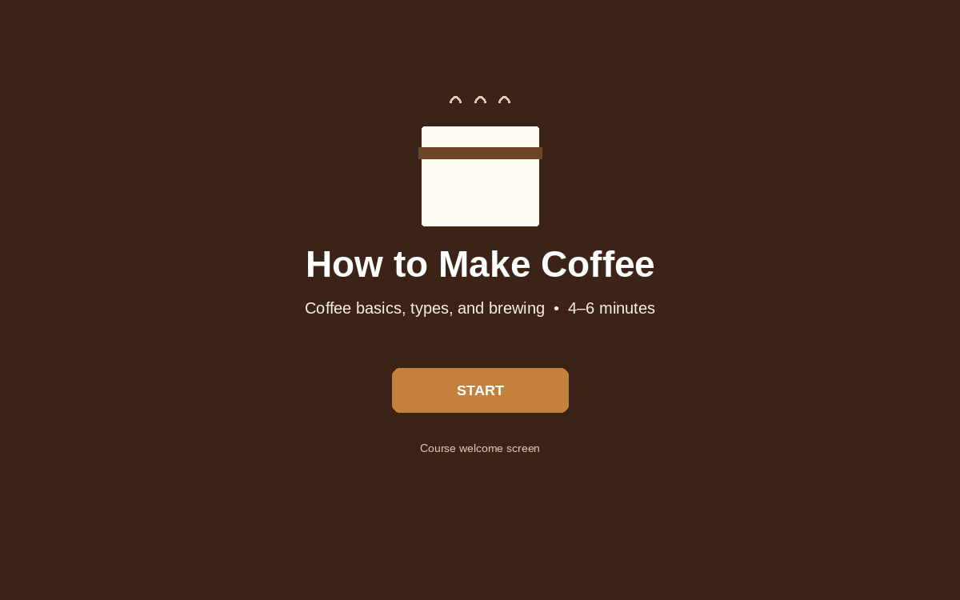
Item Naming | img_coffeeCup, txt_courseTitle, txt_subtitle, btn_start
Graphic Description
  No | Graphic Description | No | Narration
  1 | Dark brown full-screen background with a simple coffee cup icon, centered | 1 | (Soft cafe-style music — no voice-over)
  2 | Course title, large bold white text: "How to Make Coffee" | 2 | Welcome! Let's learn about coffee together.
  3 | Subtitle: "Coffee basics, types, and brewing • 4–6 minutes" | 3 | You will learn what coffee is, the main types, and how to make it.
  4 | "START" button, bottom-center | 4 | Let's begin!
Interaction instruction (prompt) | Click START to begin the course.
Notes | Simple, friendly English throughout the course — short sentences, easy words. btn_start states: Normal / Hover / Visited. Progress bar hidden on this screen; first appears on Screen 2.
Glossary
Search Keywords | coffee, beginner guide, title screen, easy english

ID Name | CFE_S02_AboutCoffee
Screen Type | Static — Information
Screen Template | Fact List Template
Screen Number | 02
Chapter Title | How to Make Coffee
Lesson Title | Lesson 1 — Introduction
Topic Title | What Is Coffee?
Screen
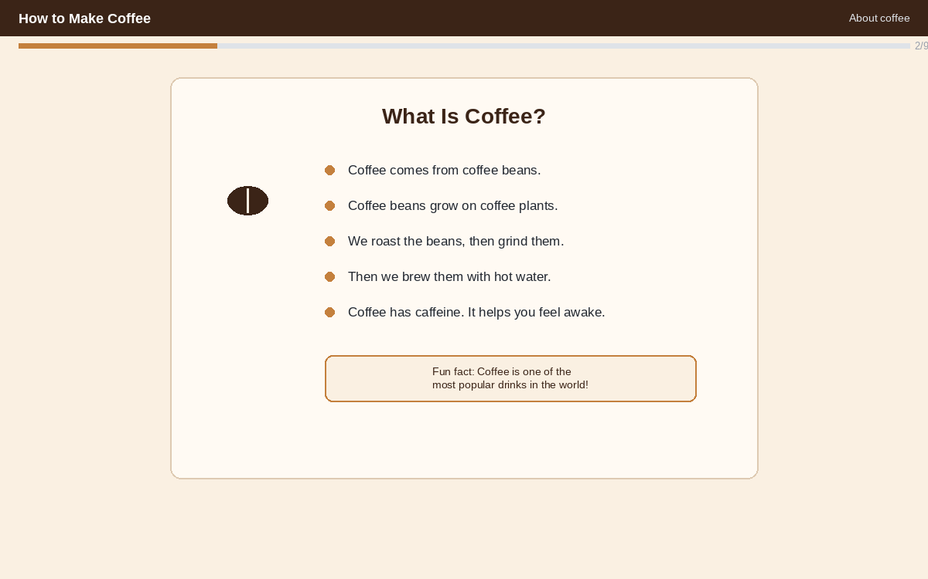
Item Naming | img_coffeeBean, list_facts, txt_funFact
Graphic Description
  No | Graphic Description | No | Narration
  1 | A simple coffee bean icon on the left | 1 | Let's start with the basics.
  2 | 5 short fact bullets: coffee comes from beans, beans grow on coffee plants, we roast and grind them, then brew with hot water, coffee has caffeine which helps you feel awake | 2 | Coffee comes from coffee beans. The beans grow on coffee plants. We roast the beans, then grind them, then brew them with hot water. Coffee has caffeine — it helps you feel awake.
  3 | Fun fact box: "Coffee is one of the most popular drinks in the world!" | 3 | Fun fact — coffee is one of the most popular drinks in the world!
Interaction instruction (prompt) | Read the facts, then click Next.
Notes | Kept to very short, simple sentences (easy-English level) since this is a beginner-friendly course. No interactivity beyond Next — this screen is purely informational. Top header displays study progress indicator "%Num% / 3" (Lesson 1 of 3 in the Study section).
Glossary | Caffeine — a natural substance in coffee that helps you feel more awake and alert.
Search Keywords | coffee basics, easy english, facts, caffeine

ID Name | CFE_S03_Types
Screen Type | Interactive — Hotspot / Flip Cards
Screen Template | Hotspot Grid Template
Screen Number | 03
Chapter Title | How to Make Coffee
Lesson Title | Lesson 2 — Coffee Types
Topic Title | Types of Coffee
Screen
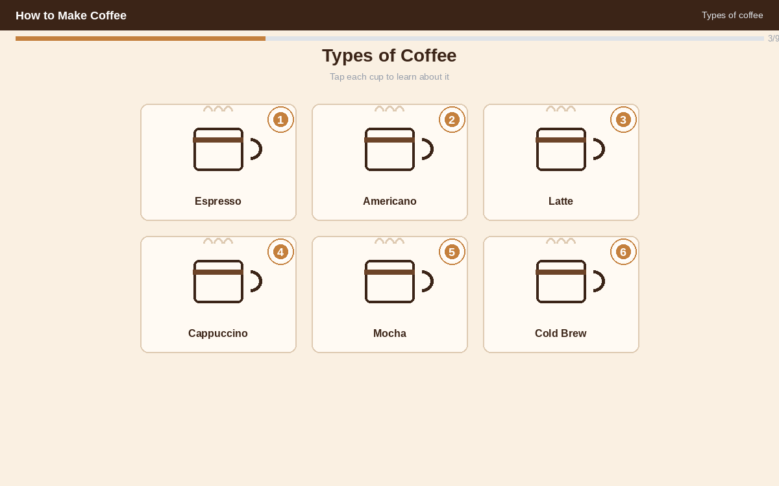
Item Naming | img_cupEspresso, img_cupAmericano, img_cupLatte, img_cupCappuccino, img_cupMocha, img_cupColdBrew, hs_1..hs_6, lyr_1..lyr_6, var_cardsSeen (count)
Graphic Description
  No | Graphic Description | No | Narration
  1 | A grid of 6 cards, each with a small coffee cup icon and a name: Espresso, Americano, Latte, Cappuccino, Mocha, Cold Brew. Each card has a numbered hotspot in the corner. | 1 | Tap each cup to learn what it is.
  2 | Layer 1 (Espresso) | 2 | Espresso: a small, strong shot of coffee.
  3 | Layer 2 (Americano) | 3 | Americano: espresso mixed with hot water. It tastes lighter.
  4 | Layer 3 (Latte) | 4 | Latte: espresso with a lot of steamed milk. Very smooth and creamy.
  5 | Layer 4 (Cappuccino) | 5 | Cappuccino: espresso with milk and a lot of foam on top.
  6 | Layer 5 (Mocha) | 6 | Mocha: espresso with chocolate and milk. Sweet and tasty!
  7 | Layer 6 (Cold Brew) | 7 | Cold Brew: coffee made with cold water. It brews slowly for many hours.
Interaction instruction (prompt) | Tap each of the 6 cups to learn about it. Then click Next.
Notes | Each card has a numbered circle (1–6) and plays audio narration describing each coffee type (Espresso, Americano, Cappuccino, Latte, Cold Brew, Mocha). Top header displays study progress indicator "%Num% / 3" (Lesson 2 of 3 in the Study section).
Glossary | Espresso — a small, strong coffee made by pushing hot water through finely-ground coffee beans under pressure.
Search Keywords | coffee types, hotspots, flip cards, espresso, latte, cappuccino

ID Name | CFE_S04_HowToMake
Screen Type | Static — Step List
Screen Template | Numbered Steps Template
Screen Number | 04
Chapter Title | How to Make Coffee
Lesson Title | Lesson 3 — Brewing
Topic Title | How to Make Coffee
Screen
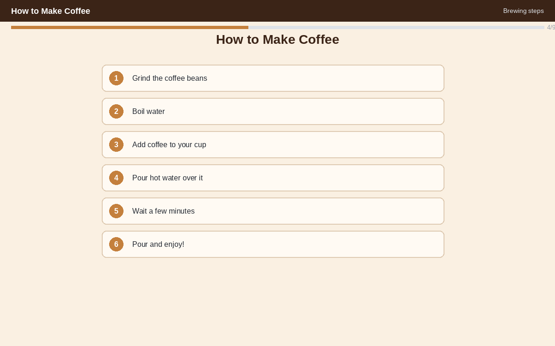
Item Naming | list_steps (6 items), img_stepIcons
Graphic Description
  No | Graphic Description | No | Narration
  1 | 6 numbered rows, each with a circle number and a short step | 1 | Here is how to make a simple cup of coffee, step by step.
  2 | 1. Grind the coffee beans | 2 | Step 1: grind the coffee beans.
  3 | 2. Boil water | 3 | Step 2: boil some water.
  4 | 3. Add coffee to your cup | 4 | Step 3: add the coffee to your cup.
  5 | 4. Pour hot water over it | 5 | Step 4: pour the hot water over the coffee.
  6 | 5. Wait a few minutes | 6 | Step 5: wait a few minutes.
  7 | 6. Pour and enjoy! | 7 | Step 6: pour it into your cup and enjoy!
Interaction instruction (prompt) | Read the 6 steps, then click Next.
Notes | Very short, simple steps — easy to follow for a first-time coffee maker. Numbered 1 to 6. Top header displays study progress indicator "%Num% / 3" (Lesson 3 of 3 in the Study section). Next button advances to the Quiz Readiness Check (Screen 05).
Glossary
Search Keywords | brewing steps, how to, easy english, beginner

ID Name | CFE_S05_ReadyCheck
Screen Type | Interactive — Readiness Check / Decision Branching
Screen Template | Character Dialogue / Branching Template
Screen Number | 05
Chapter Title | How to Make Coffee
Lesson Title | Lesson 3 — Brewing & Study Review
Topic Title | Ready for Quiz?
Screen
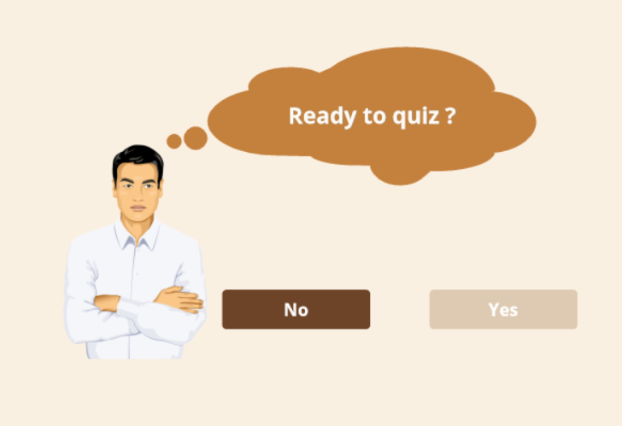
Item Naming | char_guide, bubble_speech, btn_yes, btn_no, txt_title
Graphic Description
  No | Graphic Description | No | Narration
  1 | Course title bar at top: "How to Make Coffee". Illustrated guide character centered with speech bubble: "Ready to quiz?" | 1 | Are you ready for the quiz?
  2 | "Yes" button (solid): on hover, character expression changes with speech bubble "Let’s do it!". Clicking jumps to the Quiz Scene (Screen 06). | 2 | If you're ready, click Yes to begin the quiz!
  3 | "No" button (outline): on hover, character expression changes with speech bubble "Ok, Keep Study". Clicking jumps back to Screen 02 ("What Is Coffee?") to review lessons. | 3 | If you need more practice, click No to review the lessons again.
Interaction instruction (prompt) | Click "Yes" to start the quiz, or "No" to review the study lessons.
Notes | Transition decision screen between Study and Quiz scenes. Character states: Normal ("Ready to quiz?"), Hover Yes ("Let’s do it!"), Hover No ("Ok, Keep Study"). Branching triggers: 'Yes' jumps to Quiz Scene (Screen 06); 'No' jumps back to Screen 02 (CFE_S02_AboutCoffee).
Glossary
Search Keywords | quiz readiness, knowledge check, review branching, character dialogue

ID Name | CFE_S06_QuizQ1
Screen Type | Interactive — Graded Quiz (Drag and Drop Matching)
Screen Template | Drag and Drop Question Template
Screen Number | 06
Chapter Title | How to Make Coffee
Lesson Title | Lesson 4 — Quick Quiz
Topic Title | Quiz — Question 1 of 2 (Coffee Matching)
Screen
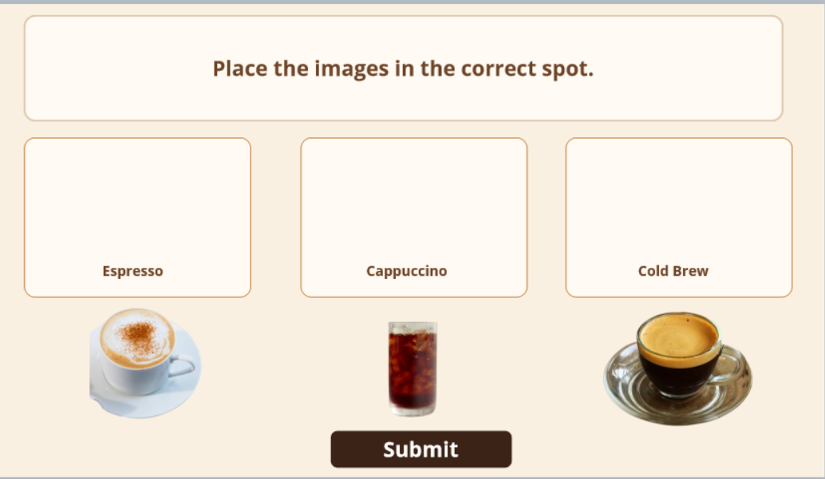
Item Naming | txt_instruction, drop_espresso, drop_coldbrew, drop_cappuccino, drag_espressoPic, drag_coldbrewPic, drag_cappuccinoPic, btn_submit, lyr_correct, lyr_incorrect, snd_espresso, snd_coldbrew, snd_cappuccino
Graphic Description
  No | Graphic Description | No | Narration
  1 | Instruction banner at top: "Place the images in the correct spot." | 1 | Place the images in the correct spot.
  2 | 3 drop target boxes labeled: "Espresso", "Cold Brew", "Cappuccino". | 2 | Match each coffee picture with its correct name.
  3 | 3 draggable coffee cup image cards. Dropping each card onto a target plays audio voiceover pronouncing the drink name ("Espresso", "Cold Brew", "Cappuccino"). | 3 | Drag each cup into its matching box.
  4 | "Submit" button at bottom right. On submit, shows Feedback Layer: Correct ("That's right! You selected the correct response.") or Incorrect ("You did not select the correct response."), each with a "Continue" button jumping to Question 2. | 4 | When you are finished, click Submit.
Interaction instruction (prompt) | Drag each coffee image onto the correct named spot, then click Submit.
Notes | Graded Drag and Drop matching interaction (10 points). Audio voiceovers play on drop ('Espresso 1.mp3', 'Cold Brew 1.mp3', 'Cappuccino 1.mp3'). Question 1 of 2 in Quiz scene. Correct/Incorrect feedback layers with Continue button jumping to Screen 07.
Glossary
Search Keywords | quiz, drag and drop, matching activity, espresso, cold brew, cappuccino

ID Name | CFE_S07_QuizQ2
Screen Type | Interactive — Graded Simulation (Hands-On Coffee Making)
Screen Template | Interactive Simulation / Process Drag & Drop Template
Screen Number | 07
Chapter Title | How to Make Coffee
Lesson Title | Lesson 4 — Quick Quiz
Topic Title | Quiz — Question 2 of 2 (Brewing Simulation)
Screen
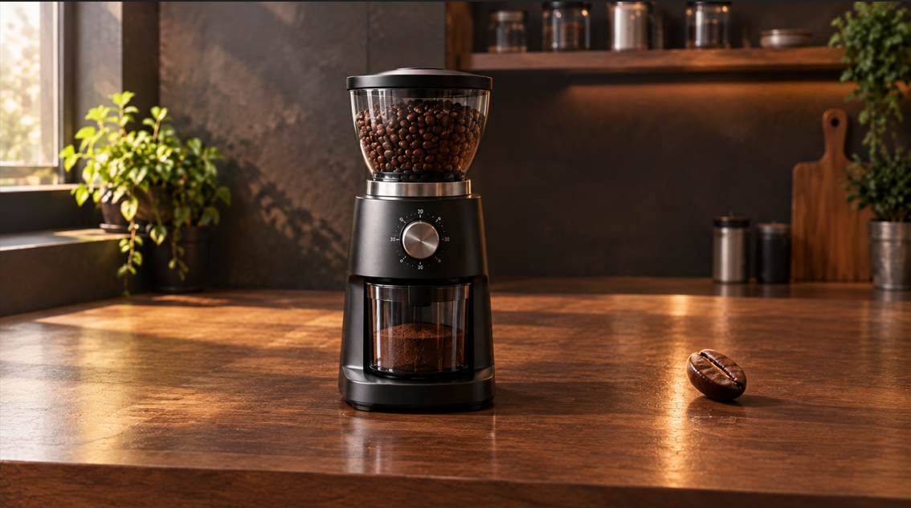
Item Naming | txt_headerPrompt, drag_beans, drop_grinder, btn_brew, btn_drink, btn_result, img_successBadge, snd_grind, snd_machine, snd_applause
Graphic Description
  No | Graphic Description | No | Narration
  1 | Prompt text: "Now, let's make coffee." Interactive kitchen / coffee bar scene with coffee beans, grinder, machine, and cup. | 1 | Now, let's make coffee!
  2 | Step 1 (Grind): Drag coffee beans to the grinder. Sound effect plays: coffee beans grinding ('Sound of coffee beans grinding 1.mp3', CC: '[Sound of coffee beans grinding]'). | 2 | First, grind your coffee beans.
  3 | Step 2 (Brew): "BREW" button activates. Clicking it triggers coffee machine sound effect ('coffee machine 1.mp3', CC: '[coffee machine]'). | 3 | Next, press BREW to run the machine.
  4 | Step 3 (Drink & Celebrate): "Drink" button activates. Clicking it triggers cheering & clapping sound effect ('sound of Hand applause for the fans 1.mp3', CC: '[sound of Hand applause for the fans]') and displays celebration banner: "You Made It". | 4 | Now enjoy your fresh cup of coffee!
  5 | Step 4 (Complete): "Result" button appears. Clicking it submits the interaction and jumps to the Results screen (Screen 08). | 5 | Great job! Click Result to see your final score.
Interaction instruction (prompt) | Follow the on-screen steps: grind the beans, click BREW, then click Drink to finish making your coffee.
Notes | Interactive gamified simulation with realistic sound effects and closed captions ([Sound of coffee beans grinding], [coffee machine], [sound of Hand applause for the fans]). Final action button 'Result' submits interaction and navigates to Screen 08 (Results). Replaces former Multiple Choice Q2 and Q3.
Glossary
Search Keywords | coffee simulation, hands on activity, brew coffee, sound effects, gamification

ID Name | CFE_S08_Results
Screen Type | Static — Results / Summary
Screen Template | Results / Summary Template
Screen Number | 08
Chapter Title | How to Make Coffee
Lesson Title | Lesson 4 — Quick Quiz
Topic Title | Your Results
Screen
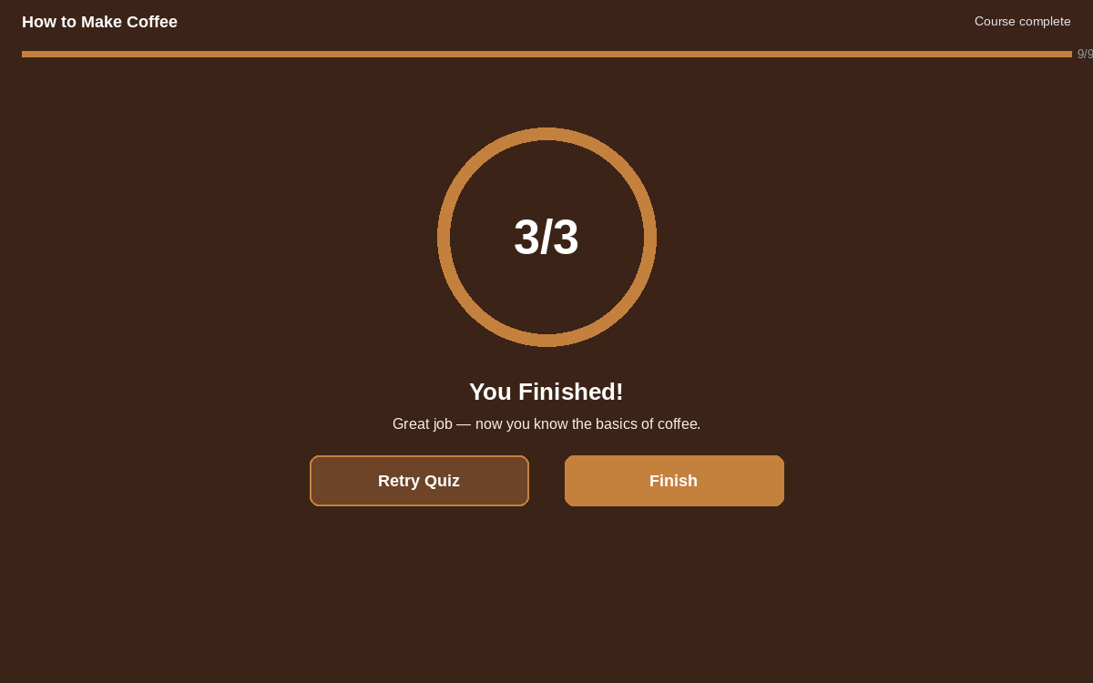
Item Naming | txt_finalScore (bound to %Quiz1.ScorePoints%), txt_headline, txt_message, btn_retryQuiz, btn_finish
Graphic Description
  No | Graphic Description | No | Narration
  1 | Donut score ring graphic displaying "%Quiz1.ScorePoints% points" | 1 | Here's how you did!
  2 | Headline: "You Finished!" · Message: "Great job – now you know the basics of coffee" | 2 | You finished! Great job — now you know the basics of coffee.
  3 | "Retry Quiz" (outline button) and "Finish" (solid button). Clicking Finish triggers exit project; clicking Retry Quiz resets Quiz1 score and restarts at Screen 06. | 3 | You can try the quiz again, or finish the course here.
Interaction instruction (prompt) | Review your score, then click Finish to exit, or Retry Quiz to try again.
Notes | txt_finalScore is bound to Storyline built-in variable %Quiz1.ScorePoints% points. Passing score = 80%. btn_finish executes exitProject action. btn_retryQuiz resets Quiz1 results and navigates to Screen 06 (CFE_S06_QuizQ1). Total course screens: 8.
Glossary
Search Keywords | final score, course completion, coffee quiz results, Quiz1.ScorePoints

